VLSI Internship – Task 3 Report

🟣 Title
Implementation of Sequential Circuits using Verilog HDL

🟣 Objective
To design and simulate basic sequential circuits such as D Flip-Flop, JK Flip-Flop, 4-bit Register, and 4-bit Counter using Verilog HDL and verify their functionality using waveform analysis.

🟣 Theory
Sequential circuits are digital circuits whose output depends on both present inputs and previous states. These circuits use memory elements like flip-flops and operate based on clock signals.
Key Concepts:
- Clock Signal: Controls timing of operations
- Flip-Flop: Basic memory element
- Register: Stores multiple bits
- Counter: Counts clock pulses
Unlike combinational circuits, sequential circuits have memory and depend on past values.

🟣 1. D Flip-Flop
🔹 Design Code:
module d_flipflop(
input clk,
input D,
output reg Q
);
always @(posedge clk)
begin
Q <= D;
end
endmodule
🔹 Testbench:
module tb;
reg clk;
reg D;
wire Q;
d_flipflop uut(.clk(clk), .D(D), .Q(Q));
always #5 clk = ~clk;
initial begin
$dumpfile("dump.vcd");
$dumpvars(0,tb);
clk = 0;
D = 0;
#10 D = 1;
#10 D = 0;
#10 D = 1;
#20 $finish;
end
endmodule
🔹 Output:
Q follows D at the positive edge of clock.
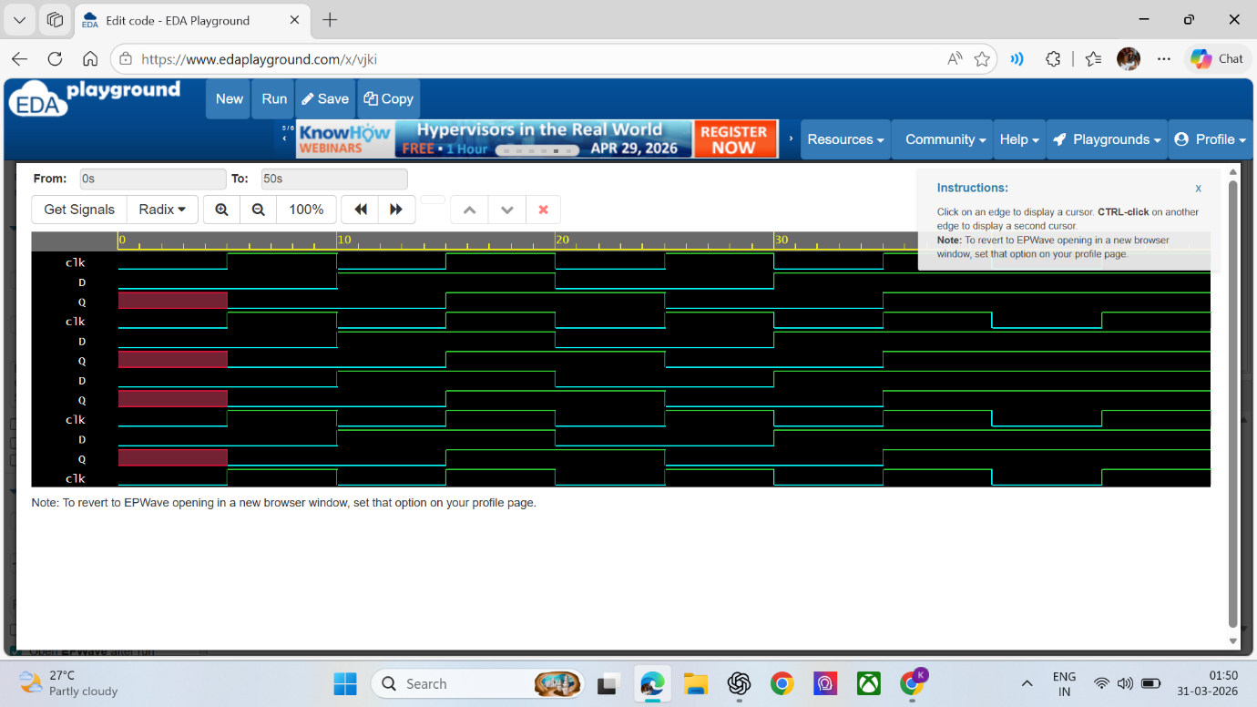

🟣 2. JK Flip-Flop
🔹 Design Code:
module jk_flipflop(
input clk,
input J,
input K,
output reg Q
);
always @(posedge clk)
begin
case({J,K})
2'b00: Q <= Q;
2'b01: Q <= 0;
2'b10: Q <= 1;
2'b11: Q <= ~Q;
endcase
end
endmodule
🔹 Testbench:
module tb;
reg clk;
reg J, K;
wire Q;
jk_flipflop uut(.clk(clk), .J(J), .K(K), .Q(Q));
always #5 clk = ~clk;
initial begin
$dumpfile("dump.vcd");
$dumpvars(0,tb);
clk = 0;
J = 0; K = 0;
#10 J=0; K=0;
#10 J=0; K=1;
#10 J=1; K=0;
#10 J=1; K=1;
#10 J=1; K=1;
#20 $finish;
end
endmodule
🔹 Output:
- 00 → No change
- 01 → Reset
- 10 → Set
- 11 → Toggle
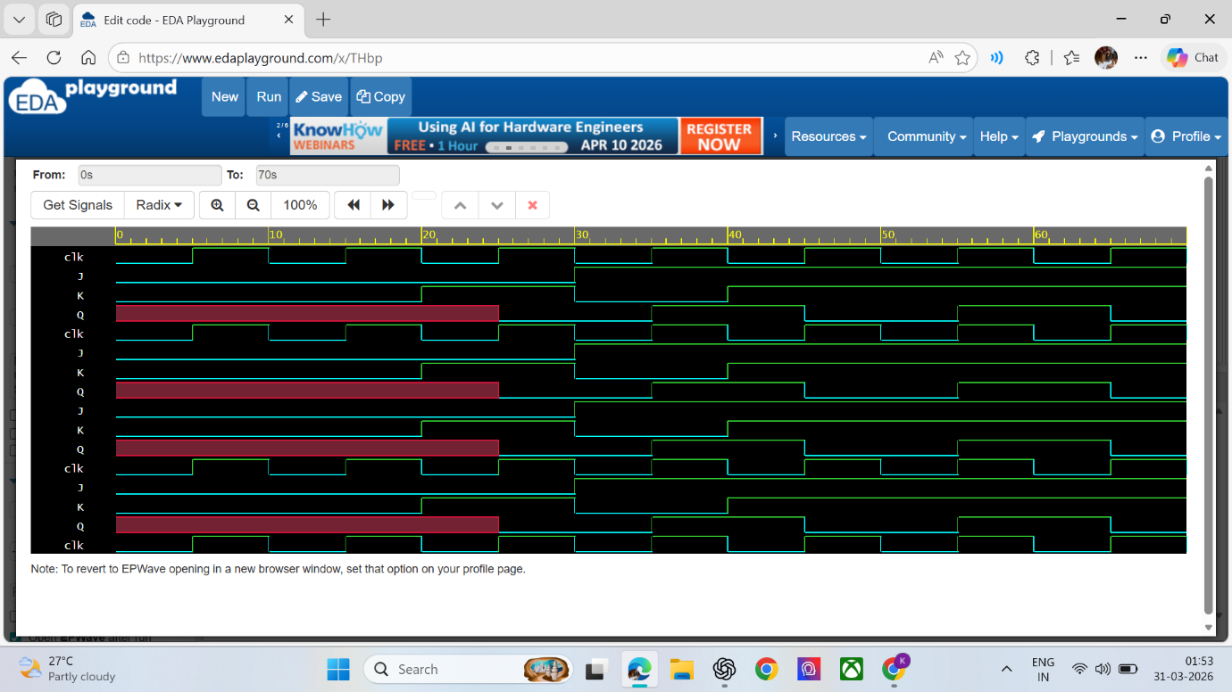
🟣 3. 4-bit Register
🔹 Design Code:
module register4(
input clk,
input [3:0] D,
output reg [3:0] Q
);
always @(posedge clk)
begin
Q <= D;
end
endmodule
🔹 Testbench:
module tb;
reg clk;
reg [3:0] D;
wire [3:0] Q;
register4 uut(.clk(clk), .D(D), .Q(Q));
always #5 clk = ~clk;
initial begin
$dumpfile("dump.vcd");
$dumpvars(0,tb);
clk = 0;
D = 4'b0000;
#10 D = 4'b1010;
#10 D = 4'b0101;
#10 D = 4'b1111;
#10 D = 4'b0001;
#20 $finish;
end
endmodule
🔹 Output:
Q stores the 4-bit input D at every clock edge.
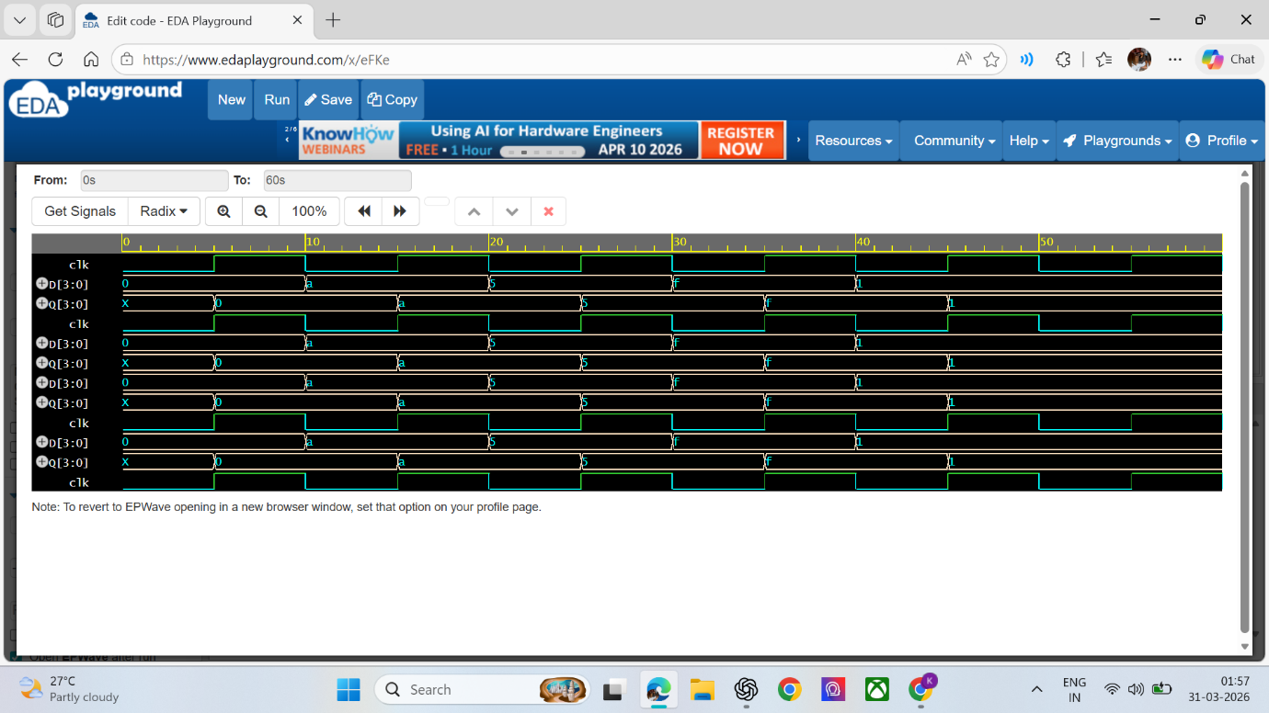
🟣 4. 4-bit Counter
🔹 Design Code:
module counter4(
input clk,
output reg [3:0] count
);
always @(posedge clk)
begin
count <= count + 1;
end
endmodule
🔹 Testbench:
module tb;
reg clk;
wire [3:0] count;
counter4 uut(.clk(clk), .count(count));
always #5 clk = ~clk;
initial begin
$dumpfile("dump.vcd");
$dumpvars(0,tb);
clk = 0;
#100 $finish;
end
endmodule
🔹 Output:
Counter increments on every clock pulse.
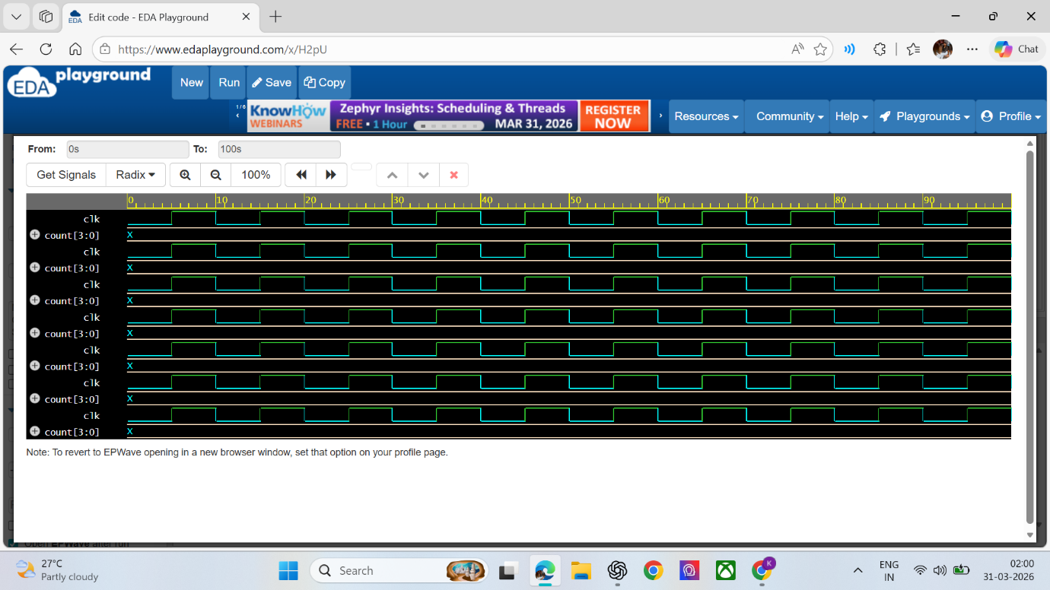

🟣 Result
All sequential circuits were successfully designed and simulated using Verilog HDL. The outputs were verified using waveform analysis.

🟣 Conclusion
This task helped in understanding the working of sequential circuits, including flip-flops, registers, and counters. It also improved practical knowledge of Verilog HDL and simulation tools.

🟣 Tools Used
- EDA Playground
- Icarus Verilog
- EPWave

